# **Metadata Audit Script**

## **Overview**

This Python script is designed to perform an audit of metadata within an XML file. It analyzes the provided XML file, extracts relevant information, and generates an Excel report with details on the data types and their status in the context of SFOA (Salesforce Objects Architecture).

## **Prerequisites**

* Python 3.x
* pandas library (pip install pandas)

## **Usage**

Close Excel File:

* Before launching the script, ensure that any existing Excel file generated by the script is closed.

Copy the path of the package (Package XML):

* Right click in VS Code and “Copy path”
* 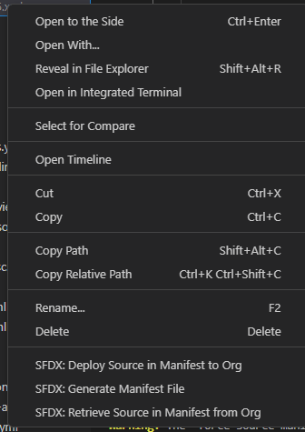

Run the Script:

* Execute the script by running the following command in your terminal:

python3 createExcelFromPackageXML.py

Input XML File:

* Enter the path of the XML file when prompted.

Output Excel File:

* The script will generate an Excel file named Audit.xlsx on your desktop. If the file already exists, a new sheet with a timestamp will be added.

Review Report:

* Open the generated Excel file to review the audit report. The report includes information about metadata members, their types, and their SFOA status.

## **Configuration**

* The script includes a list of metadata members to exclude (membersToRemove). Modify this list based on your specific requirements.

## **Notes**

* The status for each metadata member is determined based on predefined rules.
  + Expected OK: The metadata member is supported in SFOA.
  + Not supported in SFOA: The metadata member is not supported in SFOA.
  + Data Scope: Applicable only for EmailTemplate type.
  + Scope To Define: Applicable for Report and Dashboard types.

## **Author**

Shmouel Illouz